[](http://www.fas.org/index.html)[](http://www.fas.org/spp/index.html)[](http://www.fas.org/spp/military/index.html)[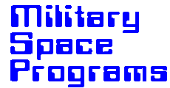](http://www.fas.org/spp/military/program/index.html)

**Kinetic Energy Anti-Satellite [KE ASAT]**

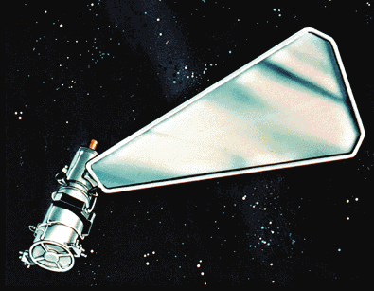Kinetic Energy Anti-Satellite (KE ASAT) program is intended to provide the United States with the capability to interdict hostile satellites. The KE ASAT consists of missile and weapon control subsystems. The major components of the missile subsystem are the booster, kill vehicle, shroud, and launch support system. The weapon control subsystem is composed of a battery control center and a mission control element which perform readiness and engagement planning, command and control. The objective of this program is to define, develop, integrate and test the necessary Kill Vehicle (KV), weapon control subsystem component and subsystems technologies to demonstrate hit to kill performance, with debris mitigation, against hostile satellites.

The government awarded a contract to Boeing North American, Incorporated, Rocketdyne Division, Canoga Park, CA as a follow-on effort to a contract which was competitively awarded in 1990. The contract exploits prior effort by a phase which will include prototype hover testing and an option for flight testing. The purpose of the effort is to directly pursue development work of the contractor hardware and software together with testing since 1990, via a follow-on development phase.

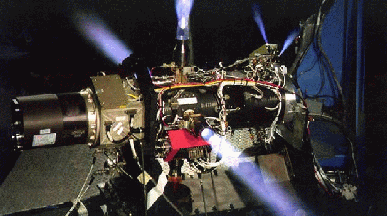This effort will consist of a hover test of the prototype KV; hardware-in-the-loop (HWIL) testing of all elements of the KE ASAT system; upgrades to tactical performance and flight qualification of the prototype KV subsystems; and debris mitigation and system integration testing to validate the system elements. Data to support the DOD Space Control Architecture study will also be provided through simulation runs and system performance estimates. Testing of the KV seeker on an airborne platform will be investigated to gather seeker performance data that would normally be demonstrated during flight testing.

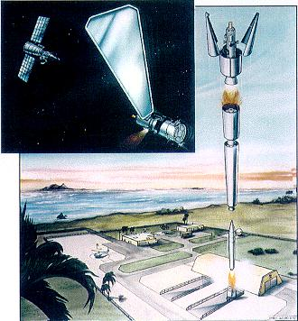A hover test of the prototype KV was conducted in August 1997 at the National Hover Test Facility to demonstrate the full-up KV free flight performance. Air bearing testing of the flight qualified KV will be conducted to allow validation of the closed-loop operation of the complete KV with actual flight software. The Weapons Control Subsystem (WCS) will be upgraded at the Army Space Operations Center (ARSPOC) to include: a Mission Control Element (MCE), Battery Control Center (BCC), and Communications Network (CN). The option will extend the period of performance for one year and will execute two flight tests.

The production of additional kill vehicles and purchase of additional boosters will be undertaken in 1998 and 1999. As a result, by 2000, the United States will have a User Operational Evaluation System (UOES) contingency capability of 10 KE-ASATs ready for use if needed, at a total cost of $205 million for the 4 years from FY96 through FY99. Projected funding is $30 million for FY96, $50 million for FY97, $80 million for FY98, and $45 million for FY99.

http://www.fas.org/spp/military/program/asat/.htm  
Maintained by [Robert Sherman](mailto:rsherman@fas.org)  
Originally created by John Pike  
Updated Monday, August 18, 1997 7:38:13 PM